AIT 524: Weekly Assignment 09
Tanmoy Chowdhury
George Mason University

Author Note
This task is being submitted as an assignment task 09 for the course ‘Database Management Essential’ offered in Sprig 2018. For any kind of inquiry, feel free to contact at tchowdh6@masonlive.gmu.edu.

Online Drill
The ERD from assignment 04 & 06 has been used here.
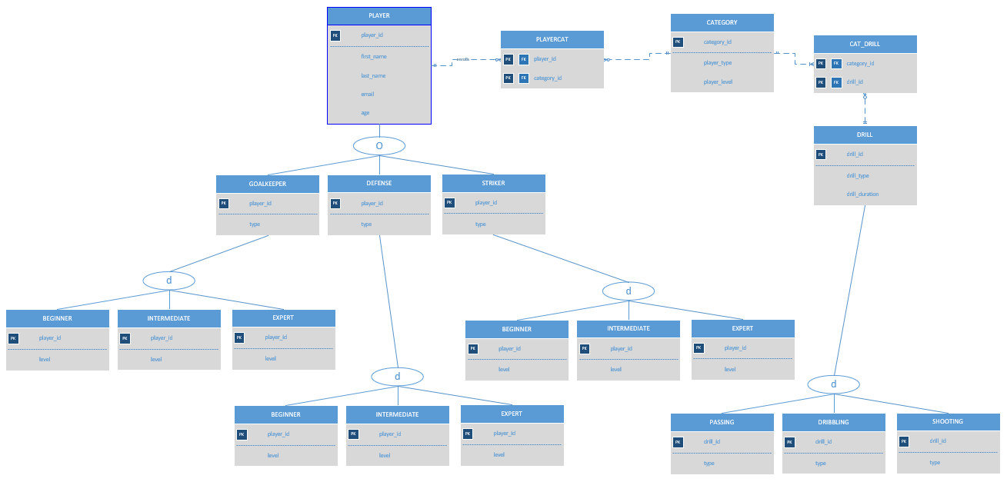
Figure 01: ERD from Assignment 04

Modification:
- I edited the entity name ‘BEGINNER’, ‘INTERMEDIATE’, ‘EXPERT’ as it seems like confusing for me when I am creating this subclass under their parent classes.
- I did not create ‘PASSING’, ‘DRIBBLING’ AND ‘SHOOTING’ entities as they inherit the same attribute from their parent class ‘DRILL’.
- I preferred to use all upper case in command and table name.

Number of data entry in entities:
- Due to my ERD, Business Rules and the Constrains applied during the creation of table I need to enter all the data in the parents table those are distributed in children table. For example, ‘PLAYER’ has 18 data entries. ‘GOALKEEPER’, ‘DEFENSE’, ‘STRIKER’ have 6 data entries each and their children have 2 data entries each.
- Based on Assignment 04, CATEGORY has total 9 data entries.
- ‘PLAYERCAT’ should contain all the ID from ‘PLAYER’ table and they are categorized based on CATEGORY table. So, ‘PLAYERCAT’ has 18 entries.
- There are only 3 types of drill. So, I entered 3 types of drill in ‘DRILL’ table.
- ‘CAT_DRILL’ should contain all the ID from ‘DRILL’ table and they are categorized based on CATEGORY table. So, right now ‘CAT_DRILL’ has 3 entries.

Presentation:
This report contains a lot of big screenshots which is difficult to trace. For your convenience, I have attached the .sql file in the assignment also.

Procedure:

- Insert into PLAYER entity:
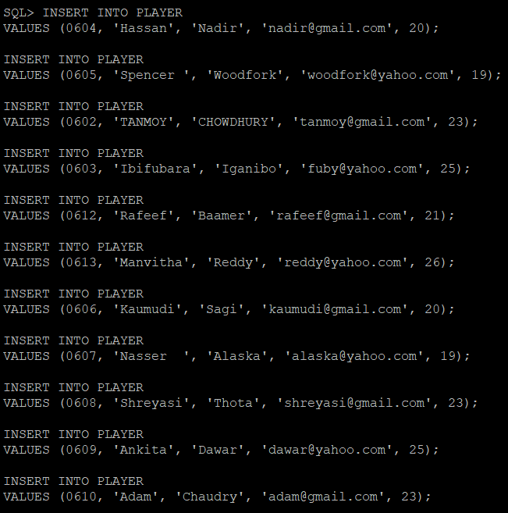
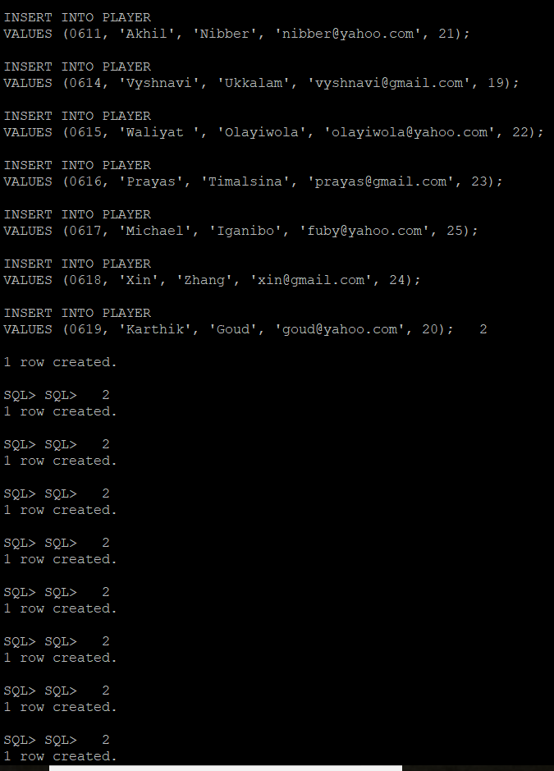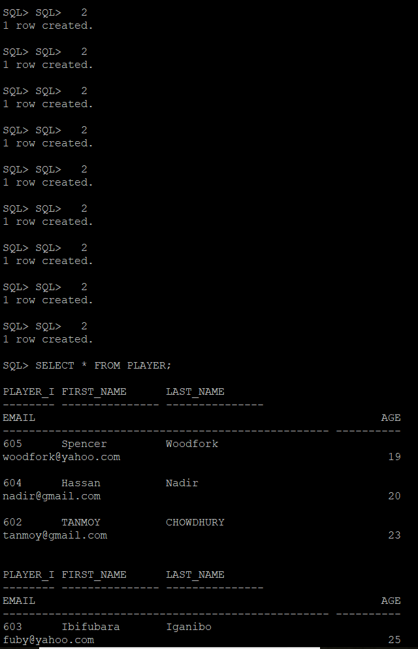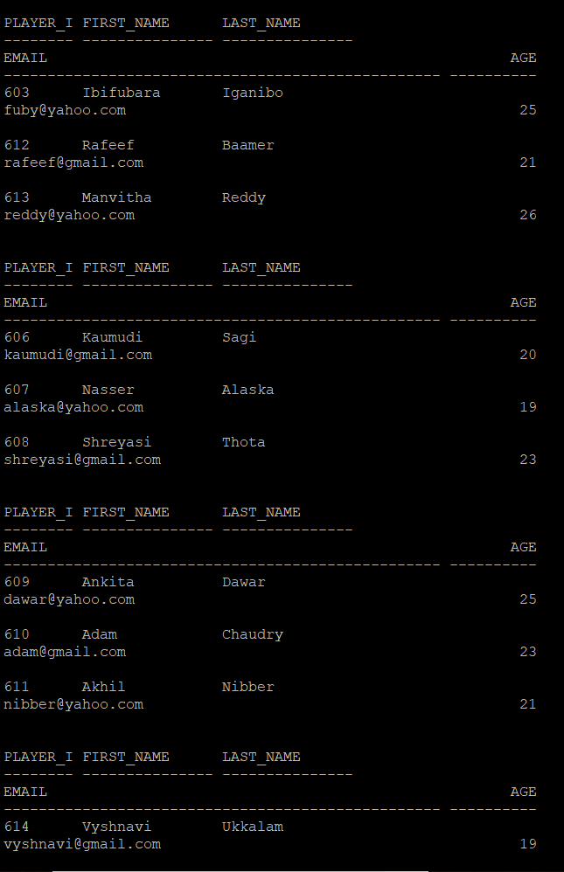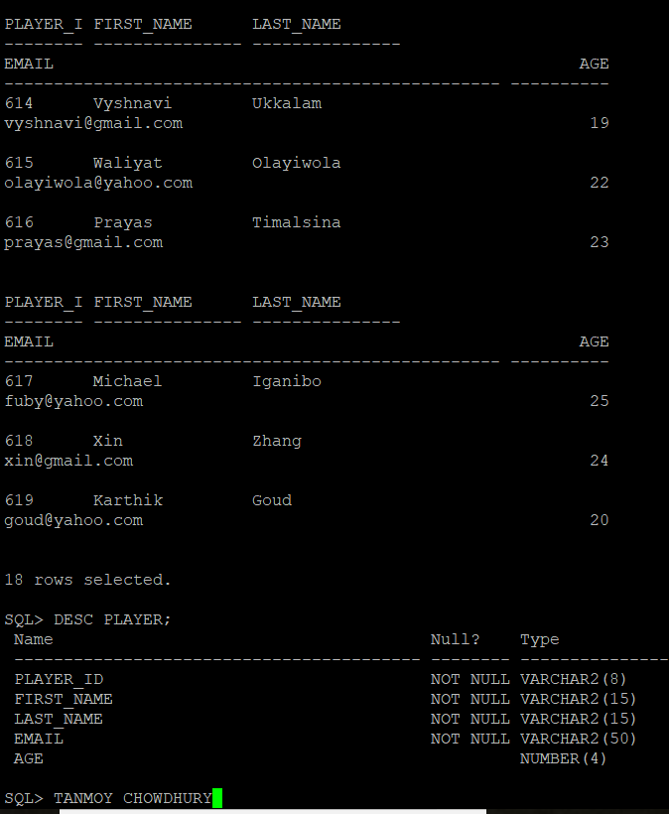

- Insert into GOALKEEPER entity:
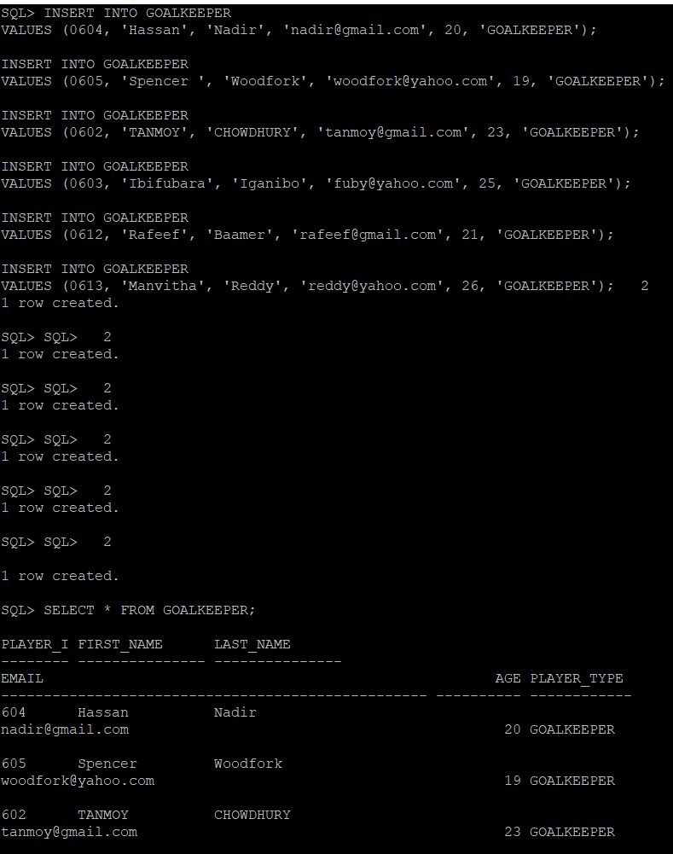

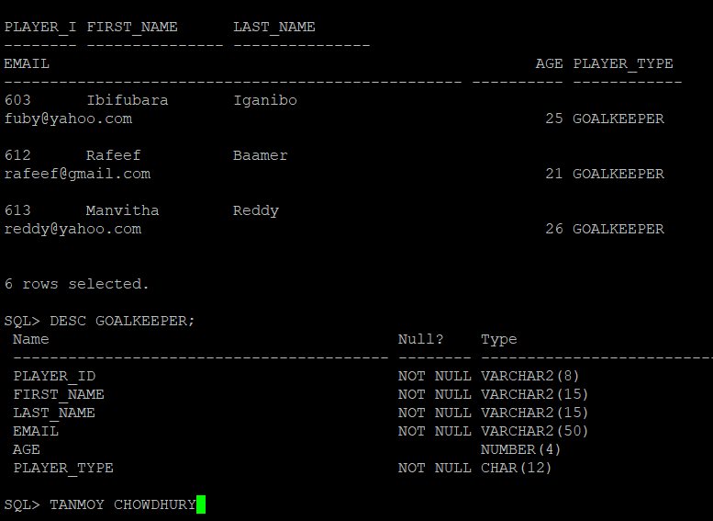

- Insert into GOALKEEPER_BEGINNER entity:

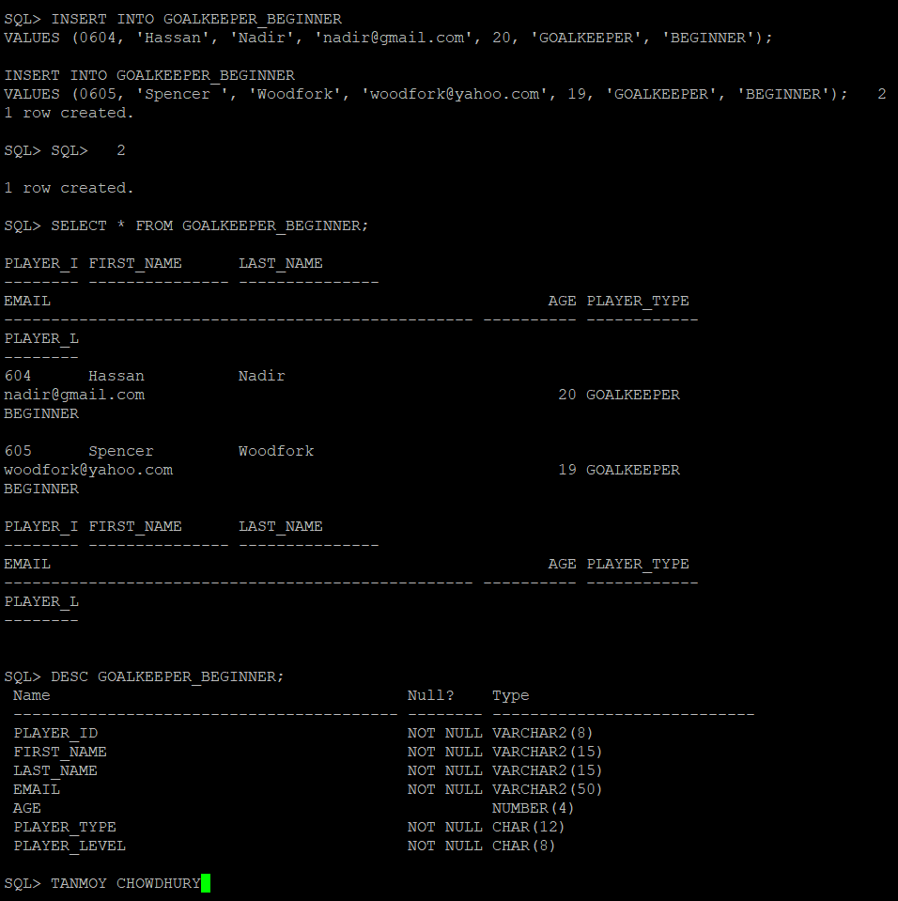

- Insert into GOALKEEPER_INTERMEDIATE entity:
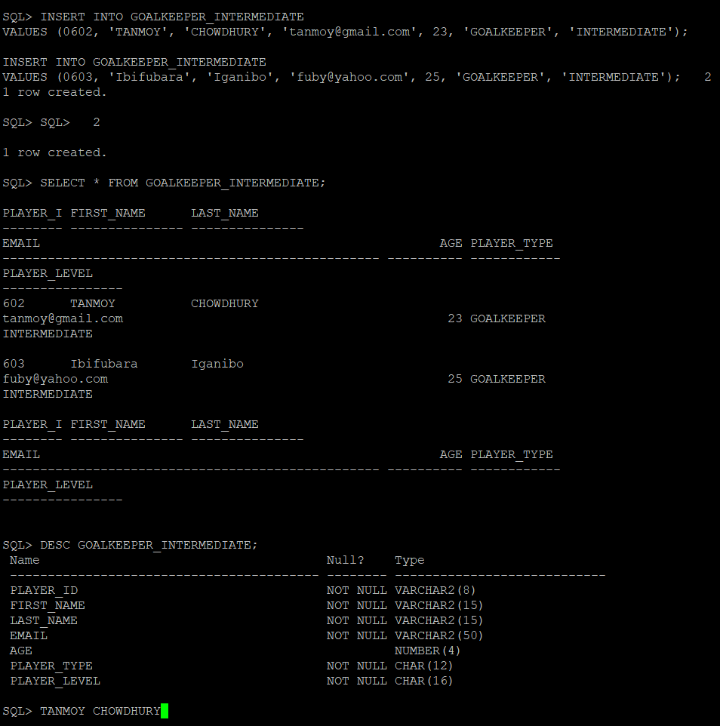

- Insert into GOALKEEPER_EXPERT entity:

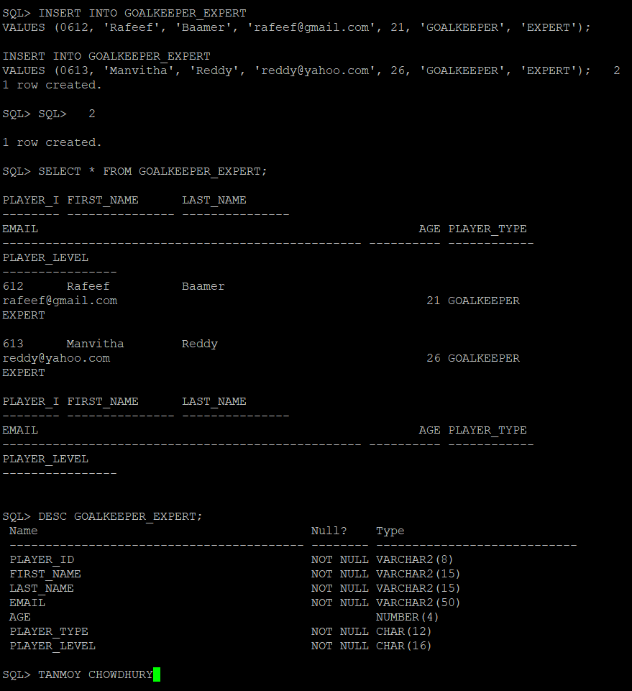

- Insert into DEFENSE entity:
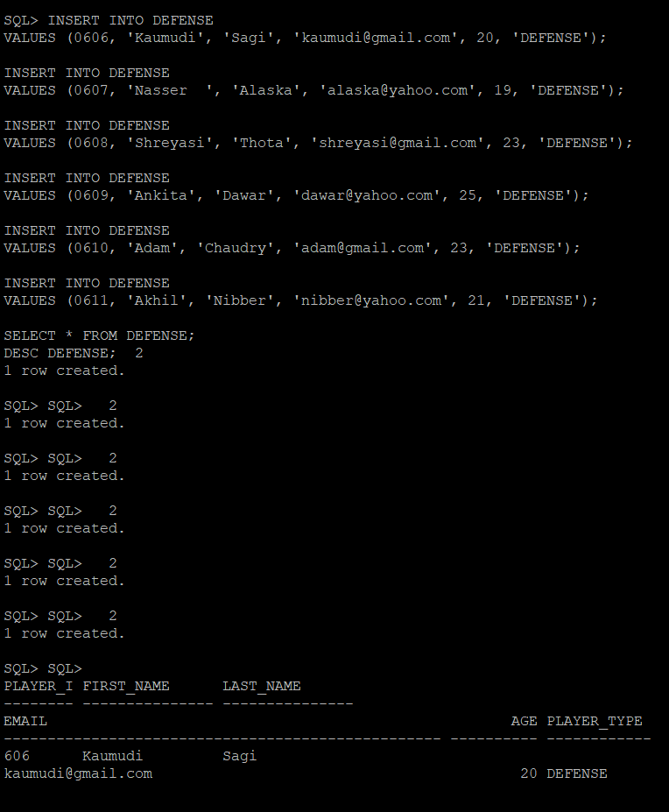
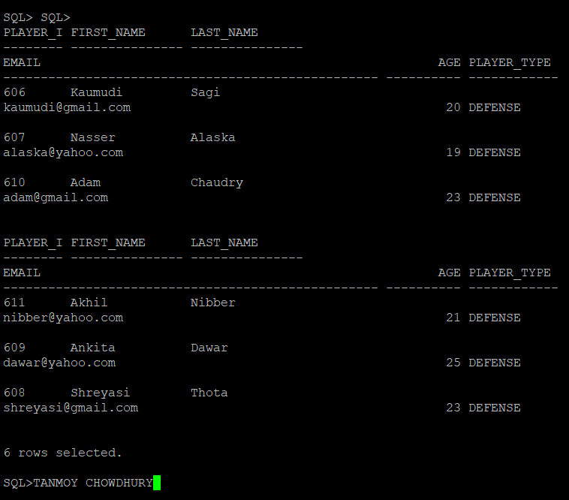

- Insert into DEFENSE _BEGINNER entity:
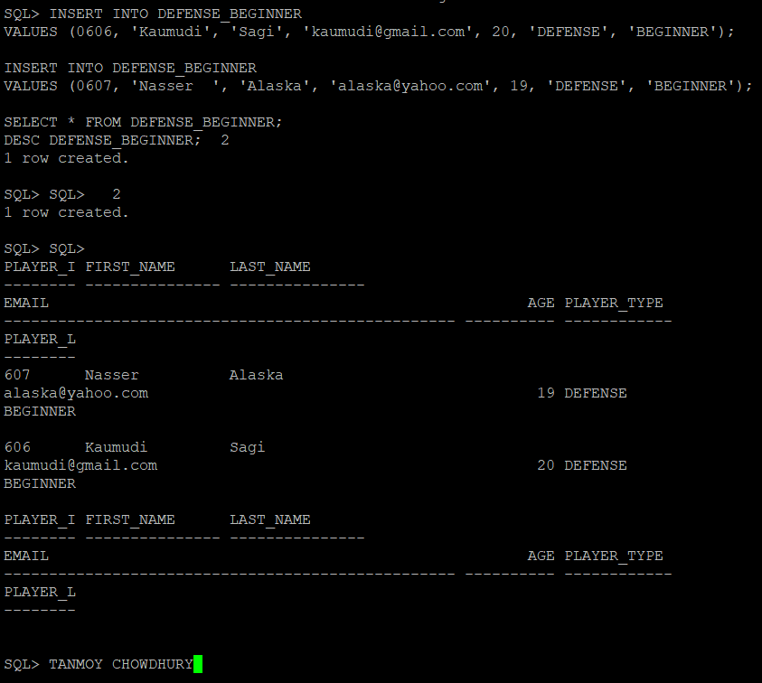

- Insert into DEFENSE _INTERMEDIATE entity:
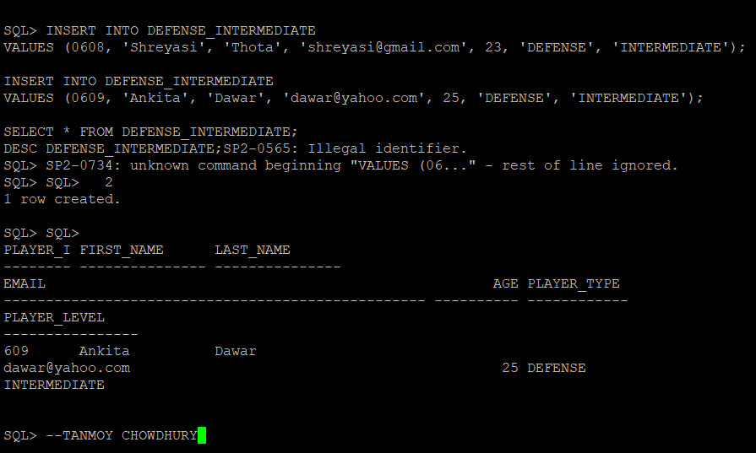

- Insert into DEFENSE _EXPERT entity:
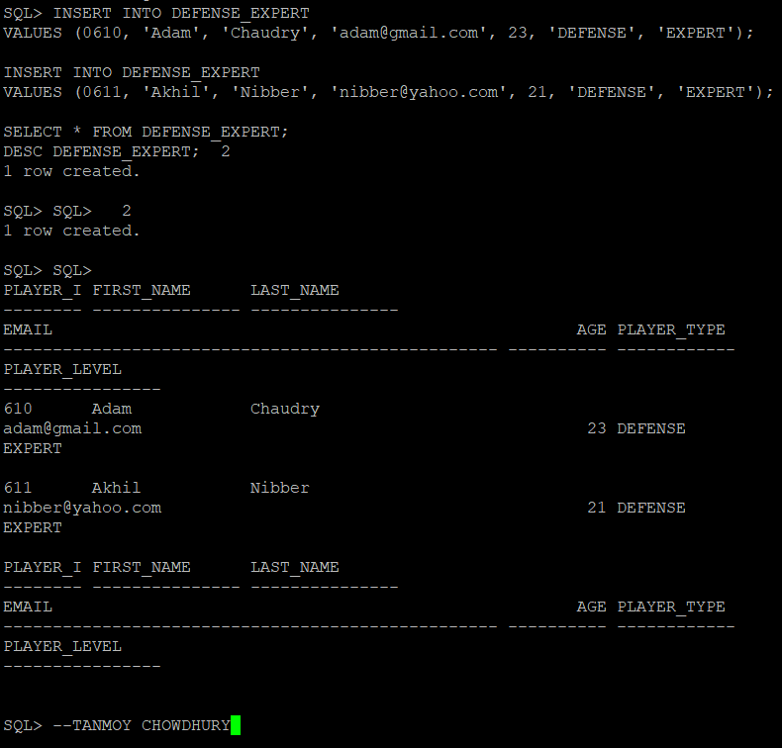

- Insert into STRIKER entity:
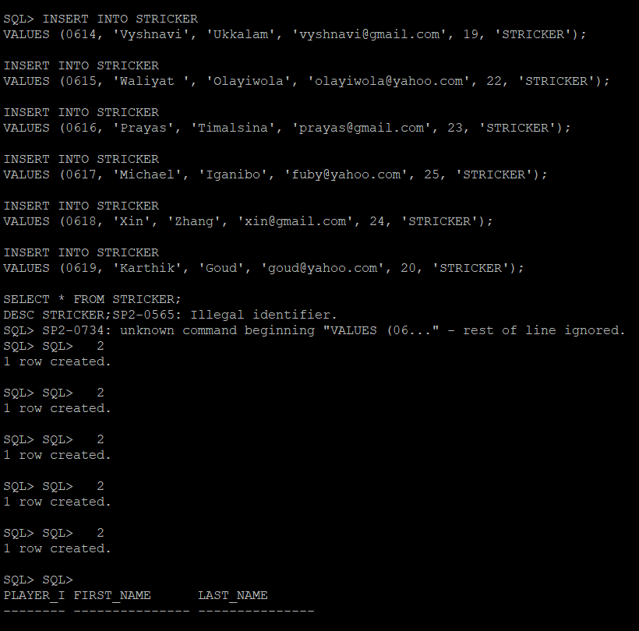
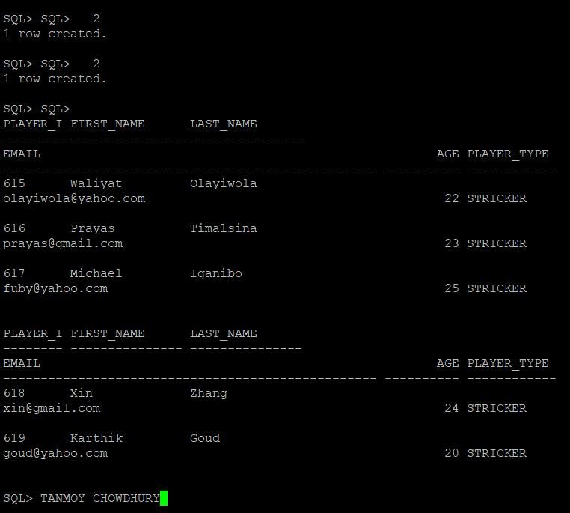

- Insert into STRIKER _BEGINNER entity:

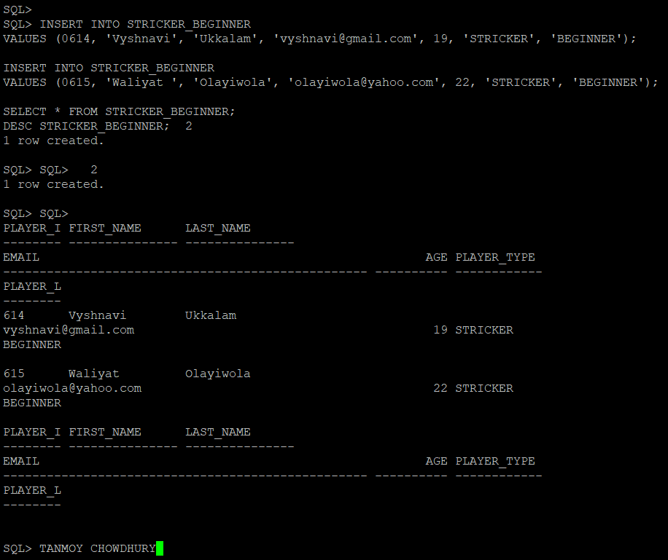

- Insert into STRIKER _INTERMEDIATE entity:
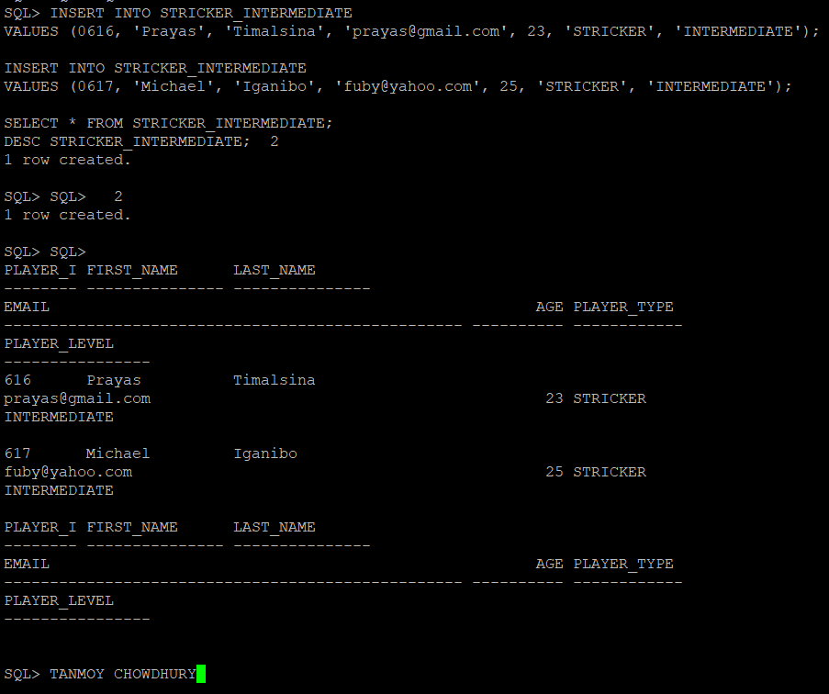

- Insert into STRIKER _EXPERT entity:
I faced illegal entry problem here. That’s why I need to put one entry again. All has been reported in the screenshot.

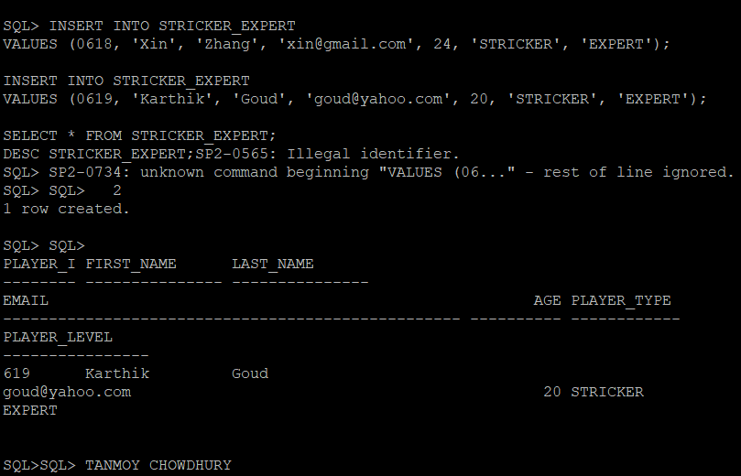
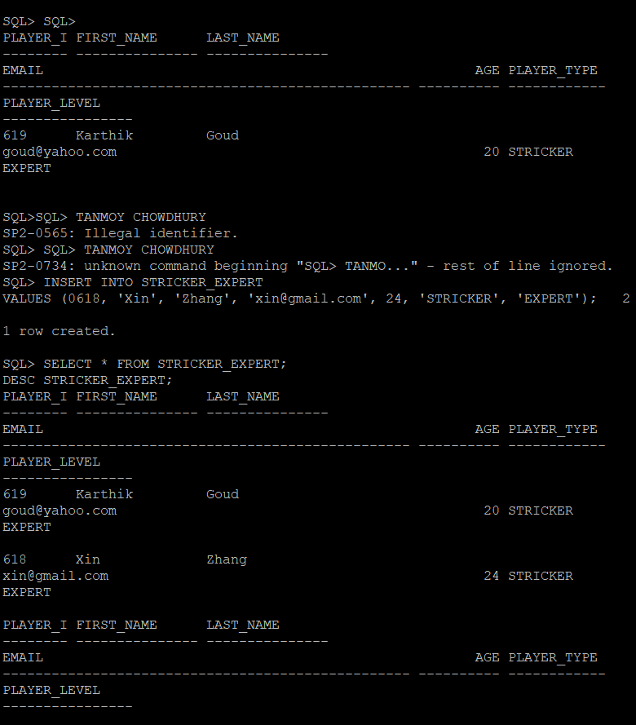

- Insert into CATEGORY entity
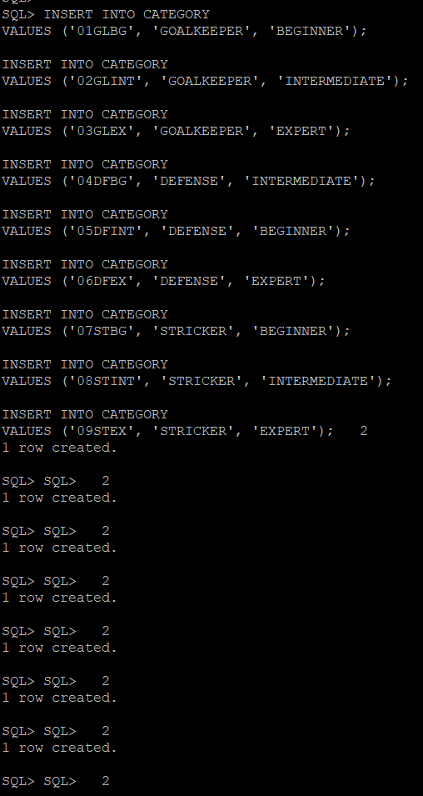
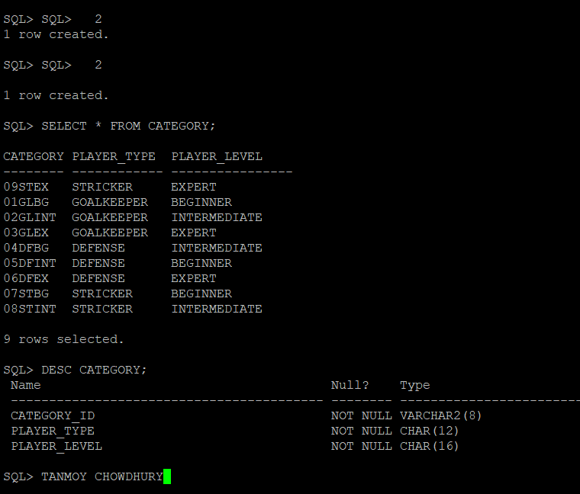

- Insert into PLAYERCAT entity
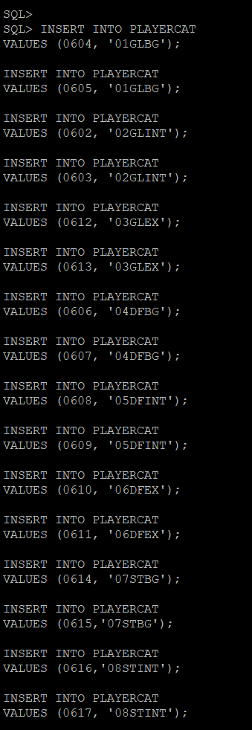
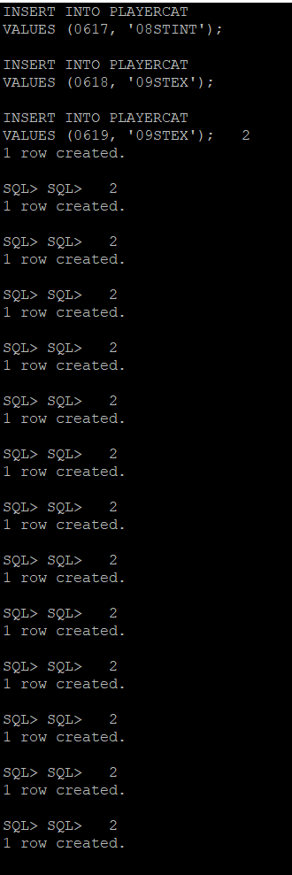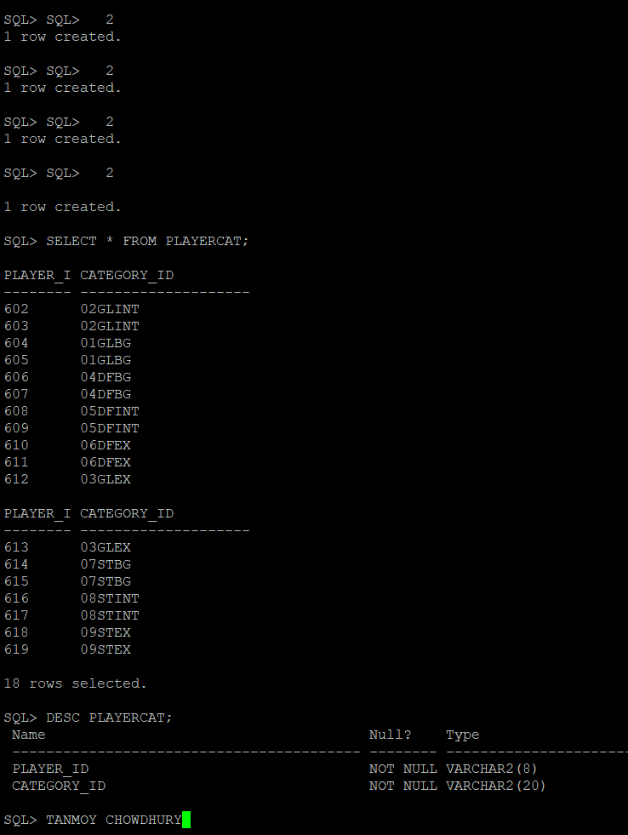

- Insert into DRILL entity
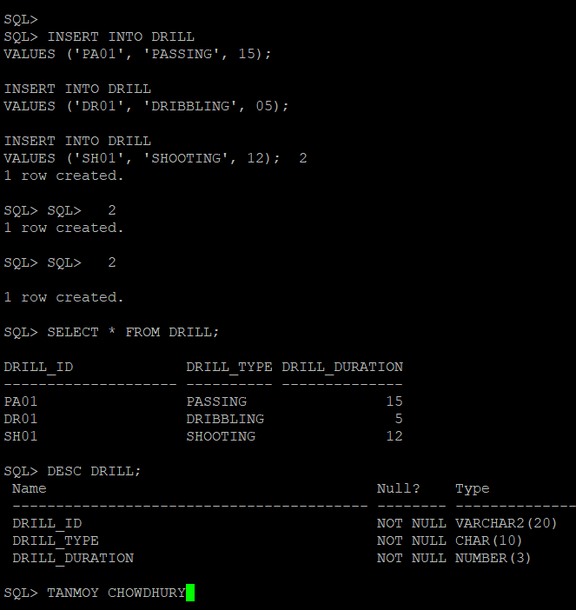

- Insert into CAT_DRILL entity
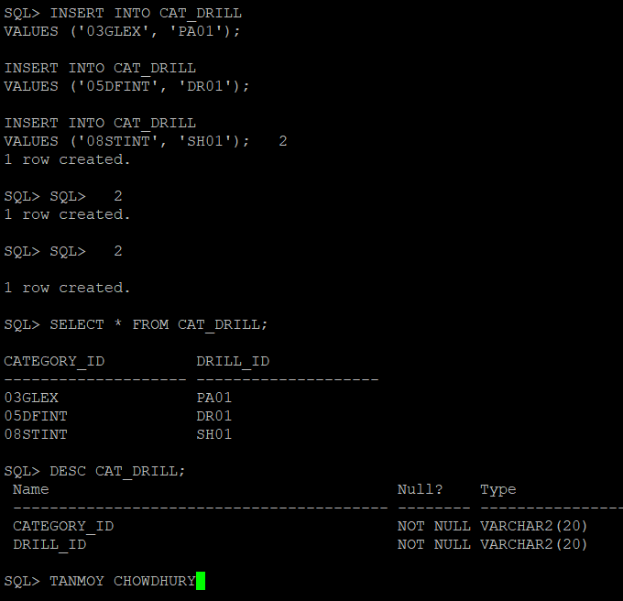

References
Casteel, J. (2016). Database system concepts and architecture in M. J. Horton, Oracle® 12c: SQL : Cengage Learning.

